**OS LAB 12**

Student Name: Neha-e-Noor

Student ID: FA17-BECE-0007

**Task1:**

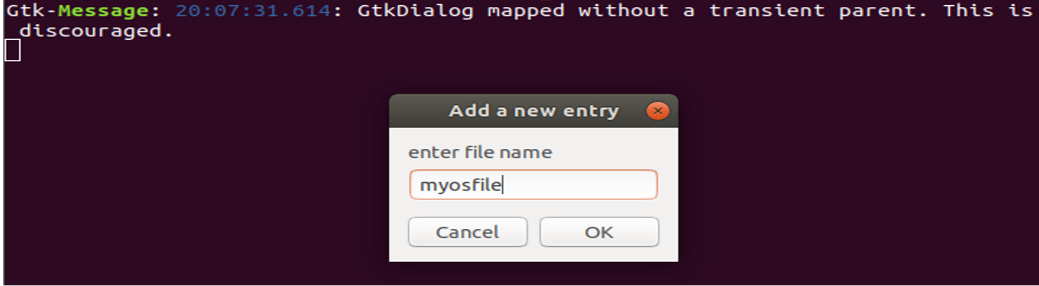

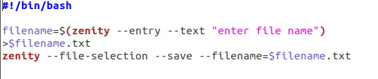

**TASK2:**

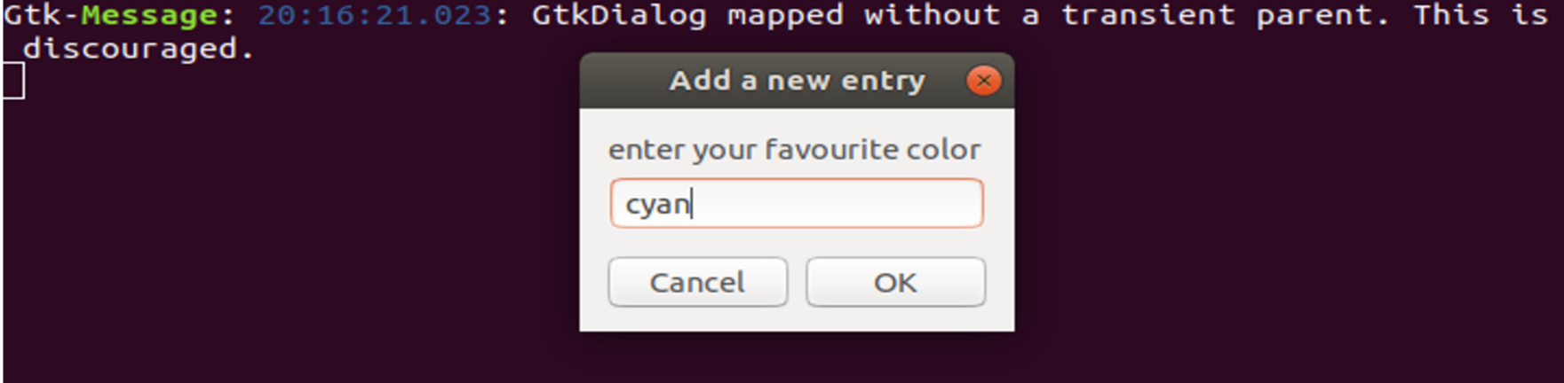

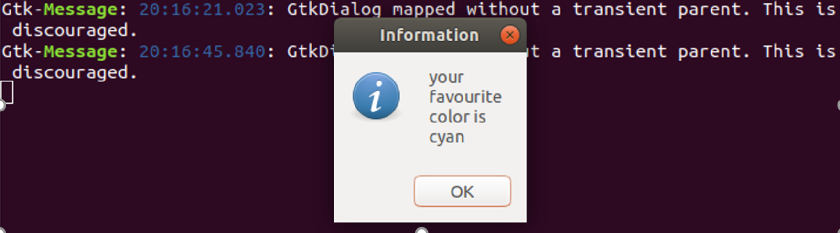

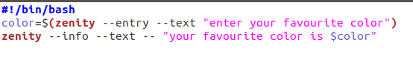

**TASK3:**

